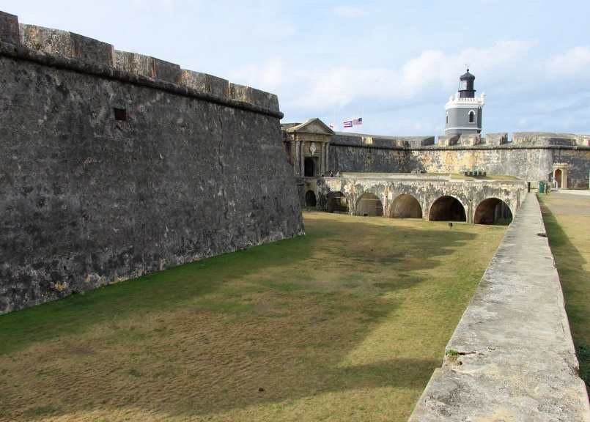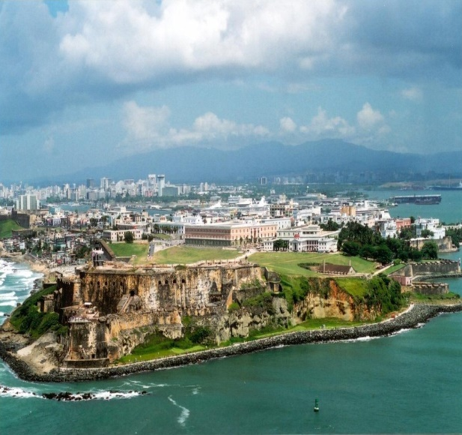

# San Juan National Historic Site

**San Juan National Historic Site** ([Spanish](https://en.wikipedia.org/wiki/Spanish_language): *Sitio Histórico Nacional de San Juan*) in the [Old San Juan](https://en.wikipedia.org/wiki/Old_San_Juan) section of [San Juan, Puerto Rico](https://en.wikipedia.org/wiki/San_Juan,_Puerto_Rico), is a [National Park Service](https://en.wikipedia.org/wiki/National_Park_Service)-managed historic site which preserves and interprets the Spanish colonial-era fortification system of the city of San Juan, and features structures such as the [San Felipe del Morro](https://en.wikipedia.org/wiki/Castillo_San_Felipe_del_Morro) and [San Cristóbal](https://en.wikipedia.org/wiki/Castillo_San_Crist%C3%B3bal_(San_Juan)) fortresses.[[3]](https://en.wikipedia.org/wiki/San_Juan_National_Historic_Site#cite_note-NPS_SJ-3) This fortification system is the oldest European construction under United States jurisdiction and one of the oldest in the New World.[[4]](https://en.wikipedia.org/wiki/San_Juan_National_Historic_Site#cite_note-4) This [national historic site](https://en.wikipedia.org/wiki/National_Historic_Site_(United_States)), together with [La Fortaleza](https://en.wikipedia.org/wiki/La_Fortaleza), have been designated a [UNESCO](https://en.wikipedia.org/wiki/UNESCO) [World Heritage Site](https://en.wikipedia.org/wiki/World_Heritage_Site) since 1983.[[5]](https://en.wikipedia.org/wiki/San_Juan_National_Historic_Site#cite_note-UNESCO-5)

## **History**

The fortification system of San Juan is closely tied to the history of the city as it defended it from foreign and [pirate attacks](https://en.wikipedia.org/wiki/Piracy_in_the_Caribbean) since its inception during the first half of the 16th century. The city walls are notable for being one of the three remaining of its kind in North America (the other two being [Quebec City](https://en.wikipedia.org/wiki/Quebec_City) in [Canada](https://en.wikipedia.org/wiki/Canada) and [Campeche](https://en.wikipedia.org/wiki/Campeche_(city)) in [Mexico](https://en.wikipedia.org/wiki/Mexico_City)).[[6]](https://en.wikipedia.org/wiki/San_Juan_National_Historic_Site#cite_note-6)[[7]](https://en.wikipedia.org/wiki/San_Juan_National_Historic_Site#cite_note-7) Three fourths of the walls remain today as a third was heavily damaged during the [1867 earthquake](https://en.wikipedia.org/wiki/1867_Virgin_Islands_earthquake_and_tsunami) and was later demolished to make way for the construction of a railway and the urban expansion of the city.[[8]](https://en.wikipedia.org/wiki/San_Juan_National_Historic_Site#cite_note-Historia_de_Puerta_de_Tierra-8) These fortifications quickly fell into disrepair after the [bombardment of San Juan](https://en.wikipedia.org/wiki/Bombardment_of_San_Juan) in 1898 during the [Spanish–American War](https://en.wikipedia.org/wiki/Spanish%E2%80%93American_War) and, although modifications and improvements were made during the [Second World War](https://en.wikipedia.org/wiki/World_War_II), the historic and architectural heritage of the site was at risk by the end of the first half of the 20th century. A federal decree on February 14, 1949, established the historic site, and noted the need to protect the fortifications as monuments as well as preserve their historical and architectural value. The fortification system was further listed on the [National Register of Historic Places](https://en.wikipedia.org/wiki/National_Register_of_Historic_Places) on October 15, 1966.

On December 6, 1983, the historic site and [La Fortaleza](https://en.wikipedia.org/wiki/La_Fortaleza) were together designated a [World Heritage Site](https://en.wikipedia.org/wiki/World_Heritage_Site) under the name [**La Fortaleza and San Juan National Historic Site in Puerto Rico**](https://en.wikipedia.org/wiki/La_Fortaleza_and_San_Juan_National_Historic_Site_in_Puerto_Rico)[[5]](https://en.wikipedia.org/wiki/San_Juan_National_Historic_Site#cite_note-UNESCO-5) "because of its outstanding, universal cultural value."[[9]](https://en.wikipedia.org/wiki/San_Juan_National_Historic_Site#cite_note-9) It quickly grew to become one of the biggest tourist attractions in Puerto Rico and the Caribbean, drawing more than 1,400,000 visitors in 2016.[[10]](https://en.wikipedia.org/wiki/San_Juan_National_Historic_Site#cite_note-:0-10) Together with the [Great Smoky Mountains National Park](https://en.wikipedia.org/wiki/Great_Smoky_Mountains_National_Park) this was the eleventh World Heritage Site to be designated in the United States and as of 2023 it is one of the [nineteen designated World Heritage Sites in the Caribbean](https://en.wikipedia.org/wiki/List_of_World_Heritage_Sites_in_the_Caribbean).[[11]](https://en.wikipedia.org/wiki/San_Juan_National_Historic_Site#cite_note-11)

The impacts of climate change on coastal communities and local community perspective are the topic of a 2015 thesis by Leslie Paul Walker, Jr.[[12]](https://en.wikipedia.org/wiki/San_Juan_National_Historic_Site#cite_note-12)